I started it by installing GNS3 from the website
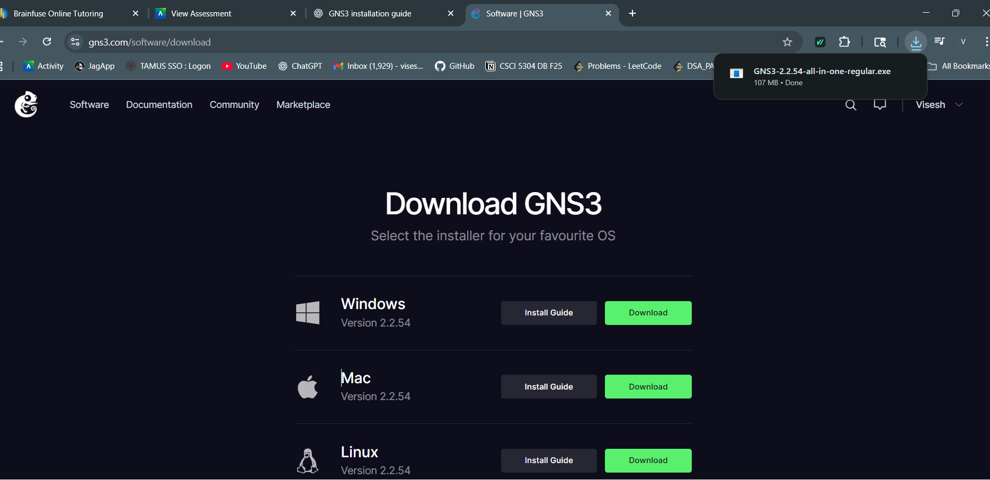
Then I opened it

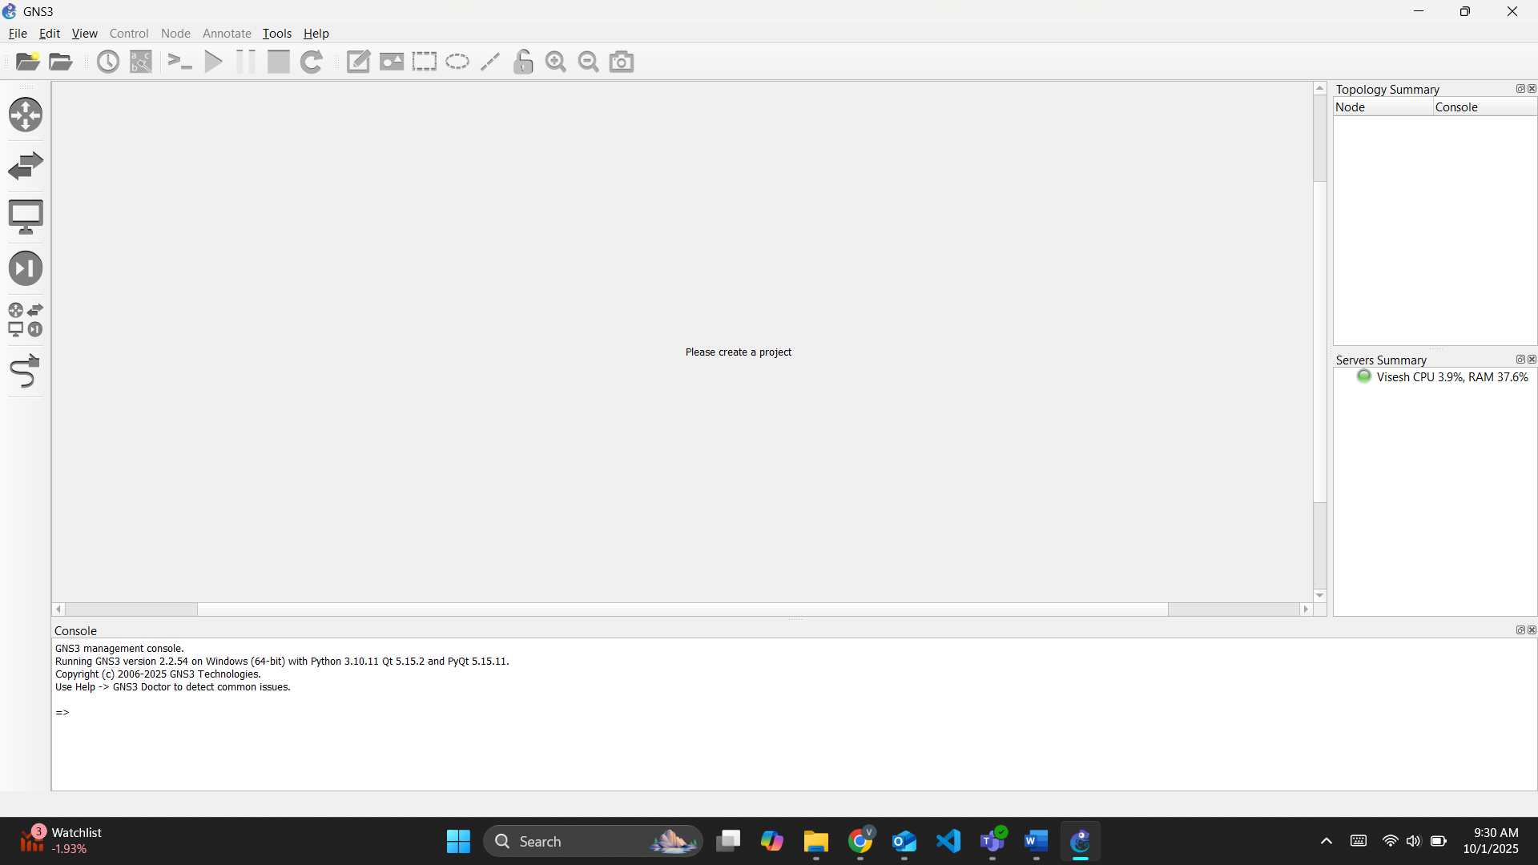

After opening it I have to click on the folder and then go to preferences and before that we have to load the image from the folder. And then I have to select he IOS image.
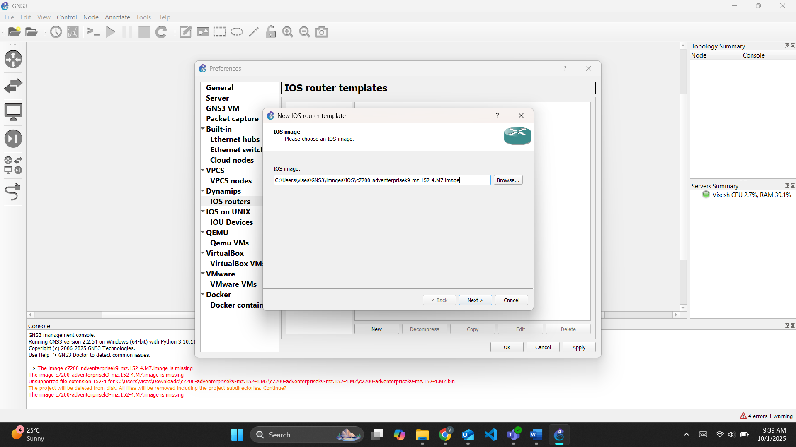
I named it c7200
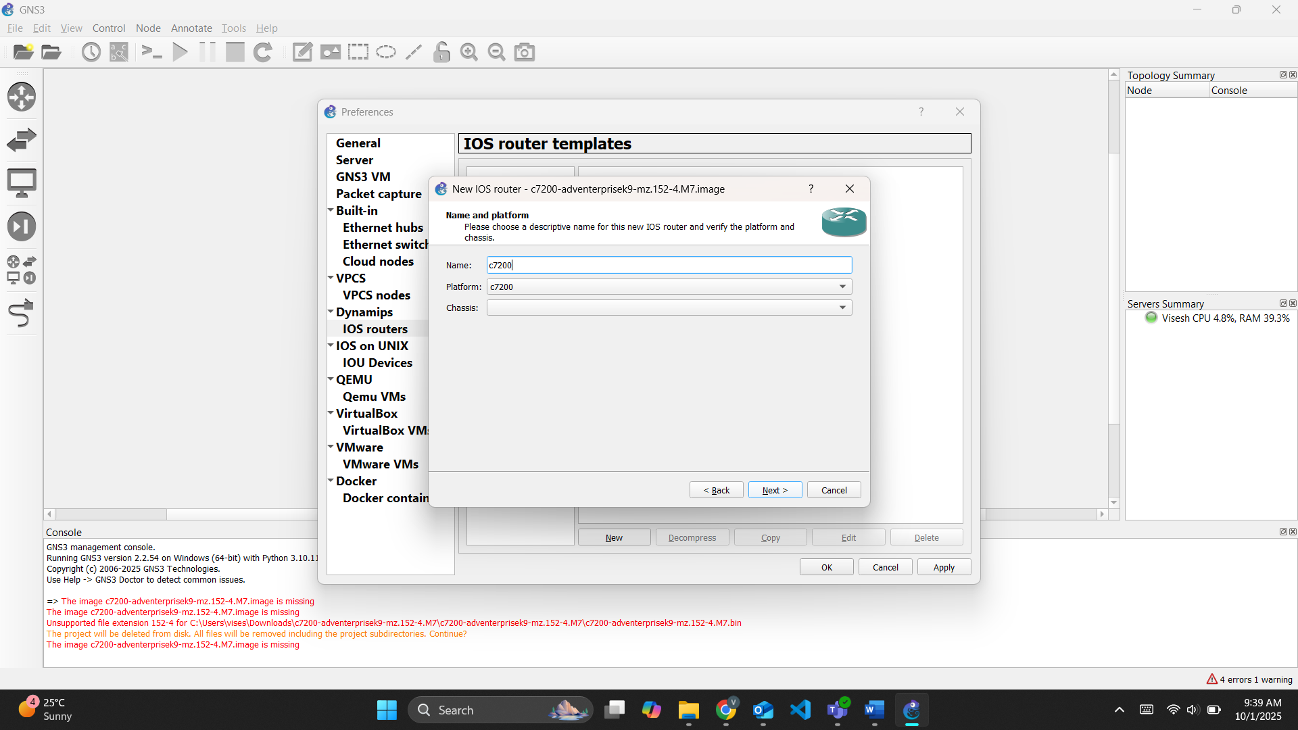

Then I select the slots for the network adapter for the router
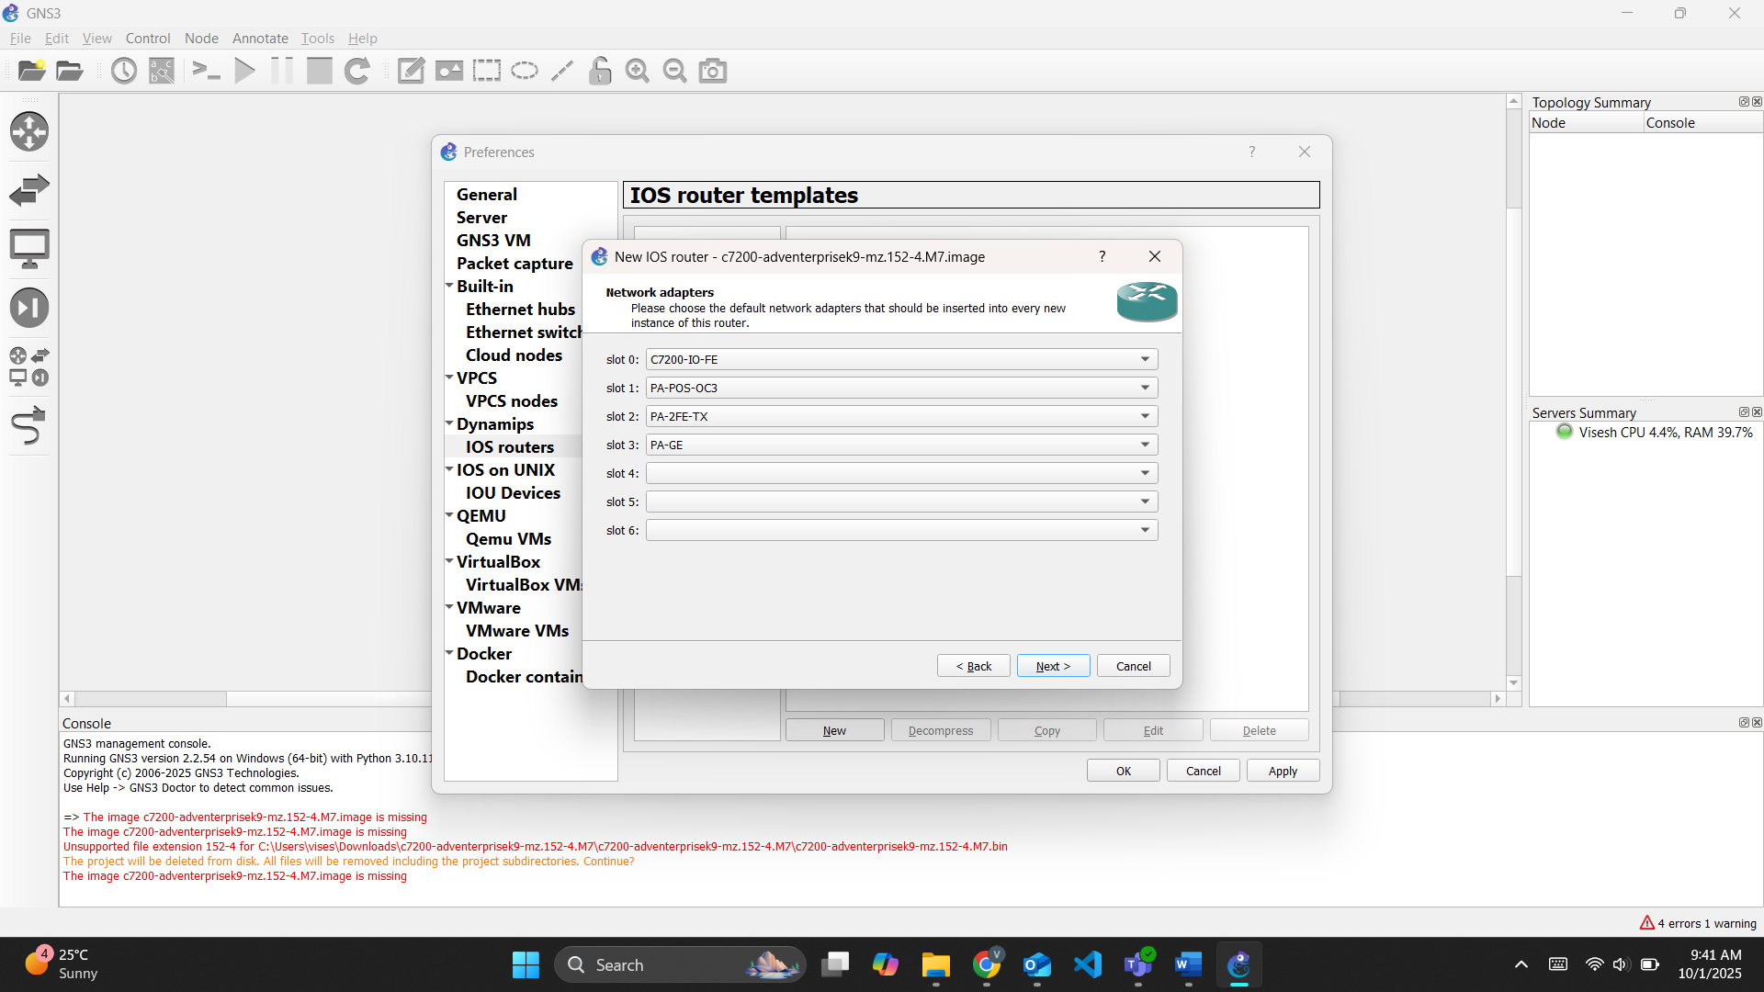
And then I made some changes to the settings as per the manual
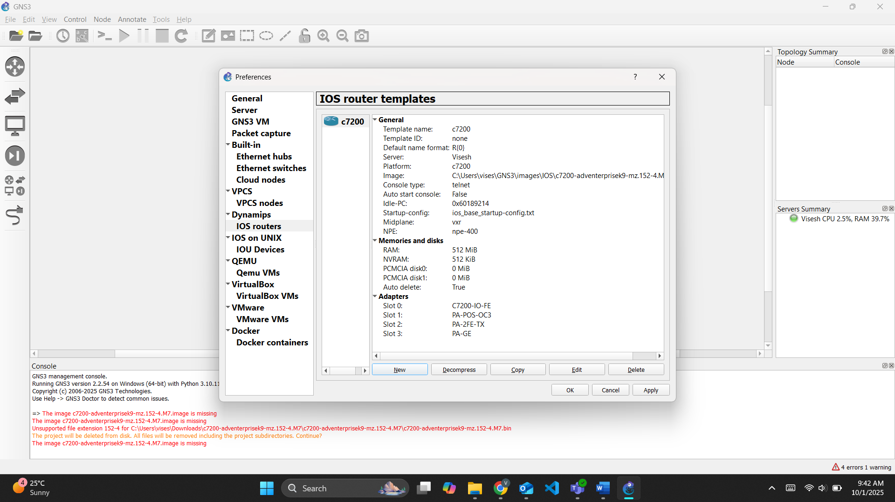

Then I dragged the 2 pcs from the left panel and the c7200 router
Then right click on it and configure it but before I added cables from the left panel. And then double click on the router and select console. Then we can a console gui opening up as below
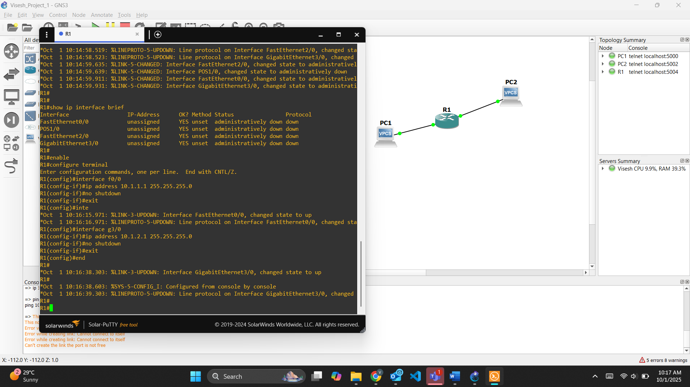
We use the codes given in the manual
And then we double click on pc1 and configure it with the code and set ip and gateway
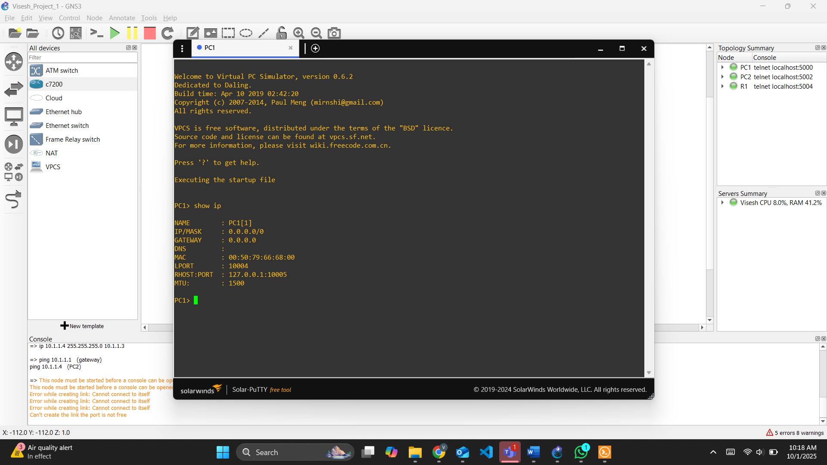
And we use showip to check if we set the ip correctly or not.
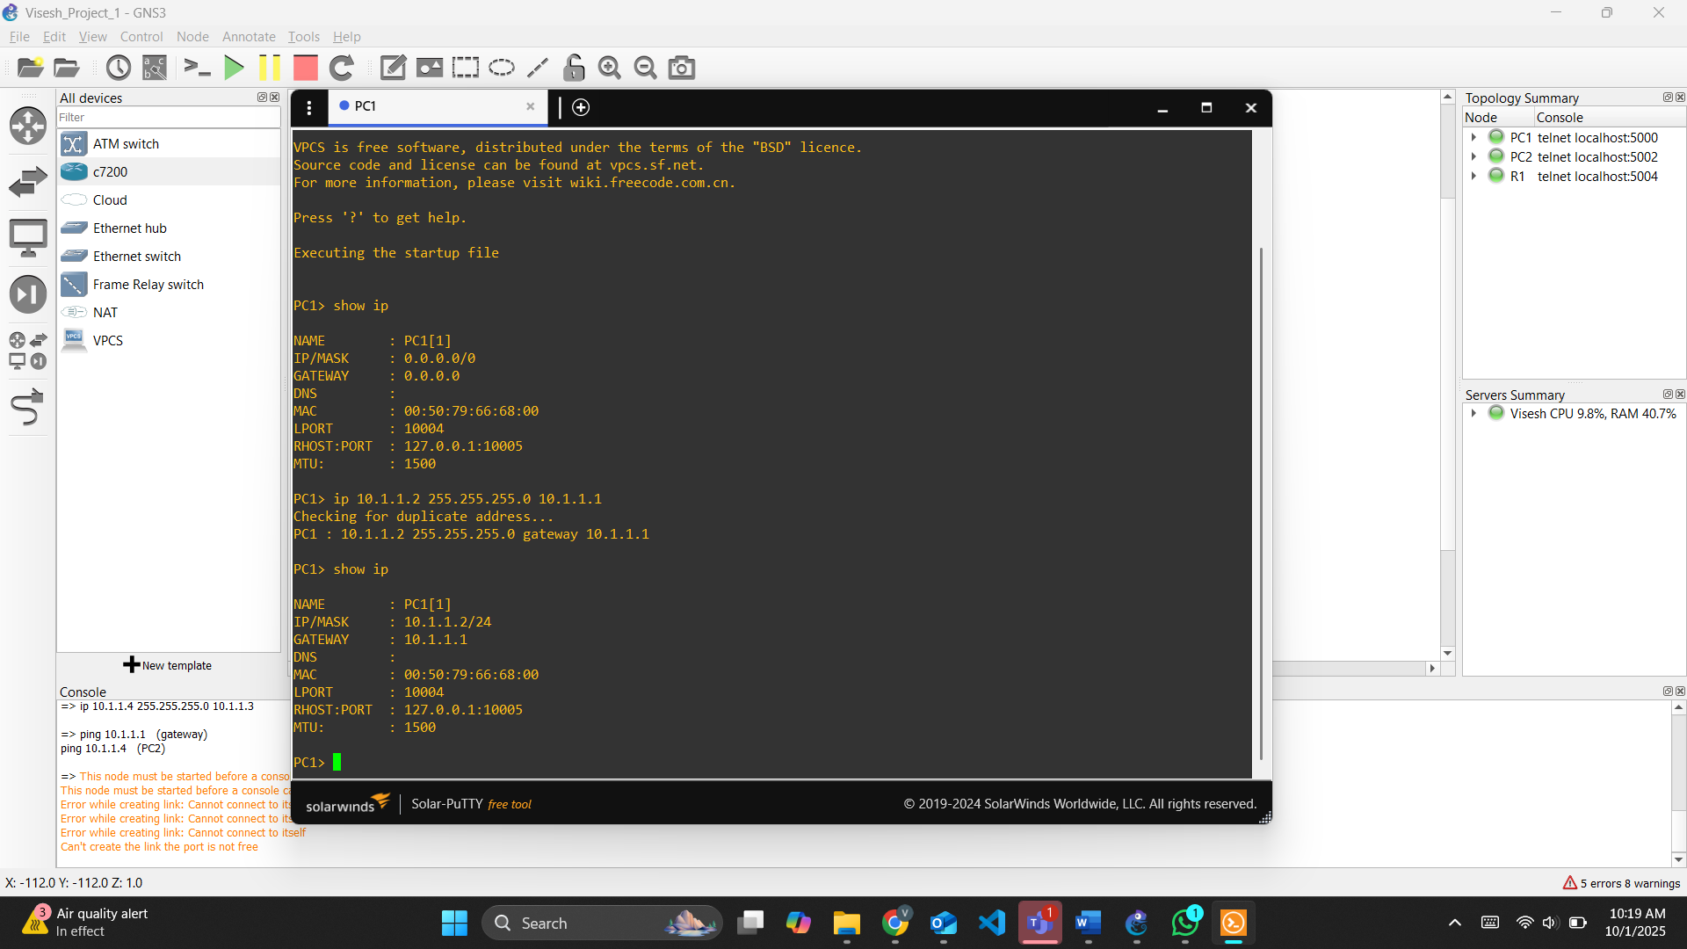
And then double click on the PC2 and do the same procedure as PC1.
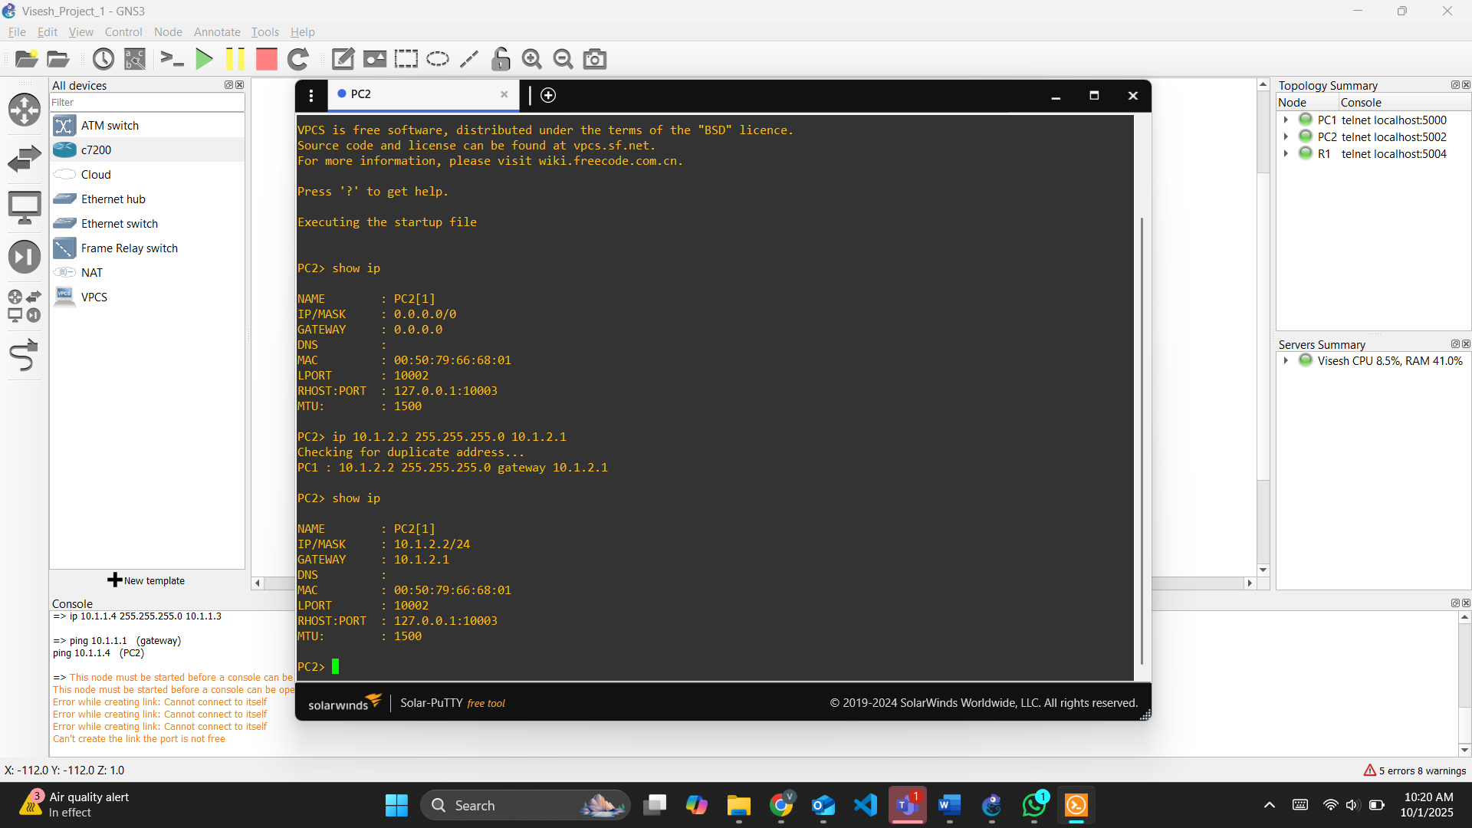
Check by typing show ip command
After the we do the ping test to check if they are connected properly.
We start with pc 1 and ping test it.
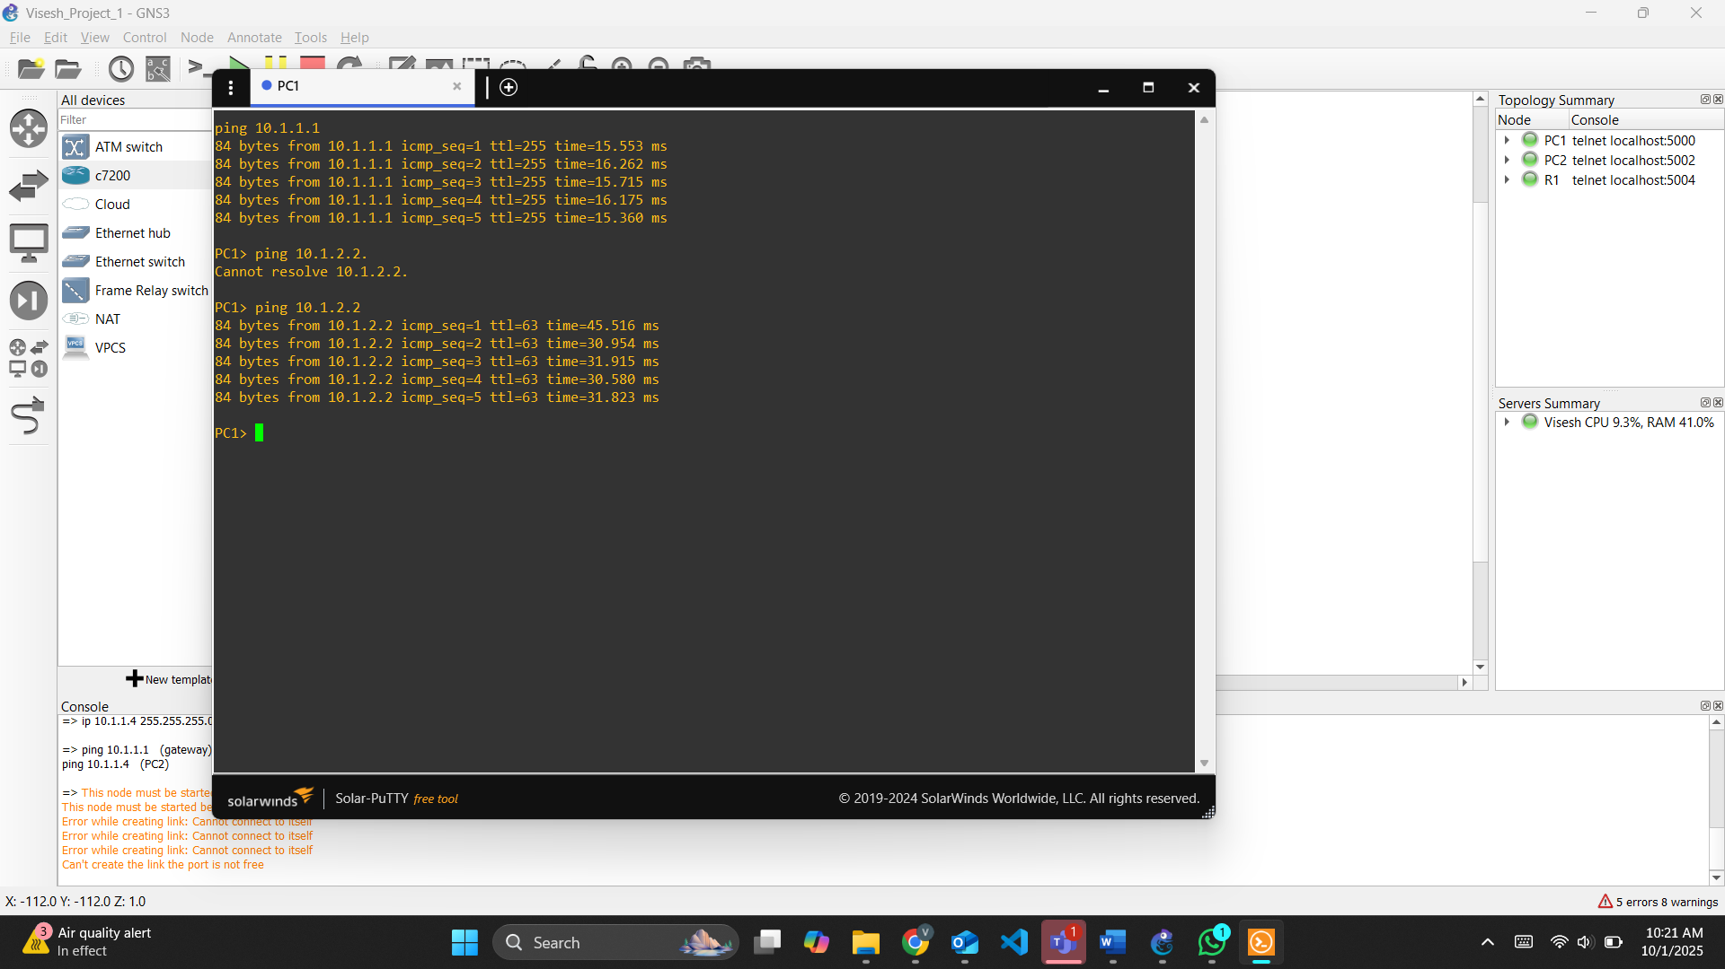
And then pc2 and ping test it..
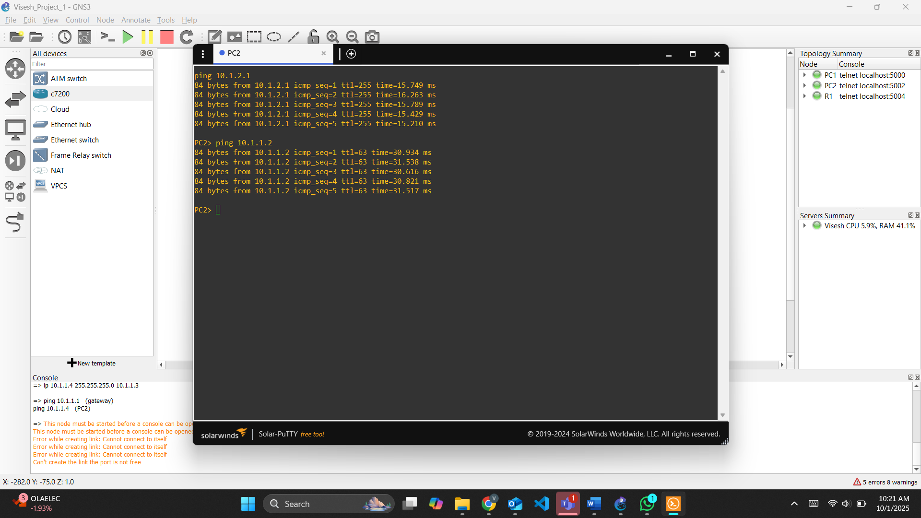
And then to check if the connectivity is there then I use the command show ip interface brief. And now we do the same thing with a different Ip address. Follow the same steps.
We can check by show ip interface brief on Router1
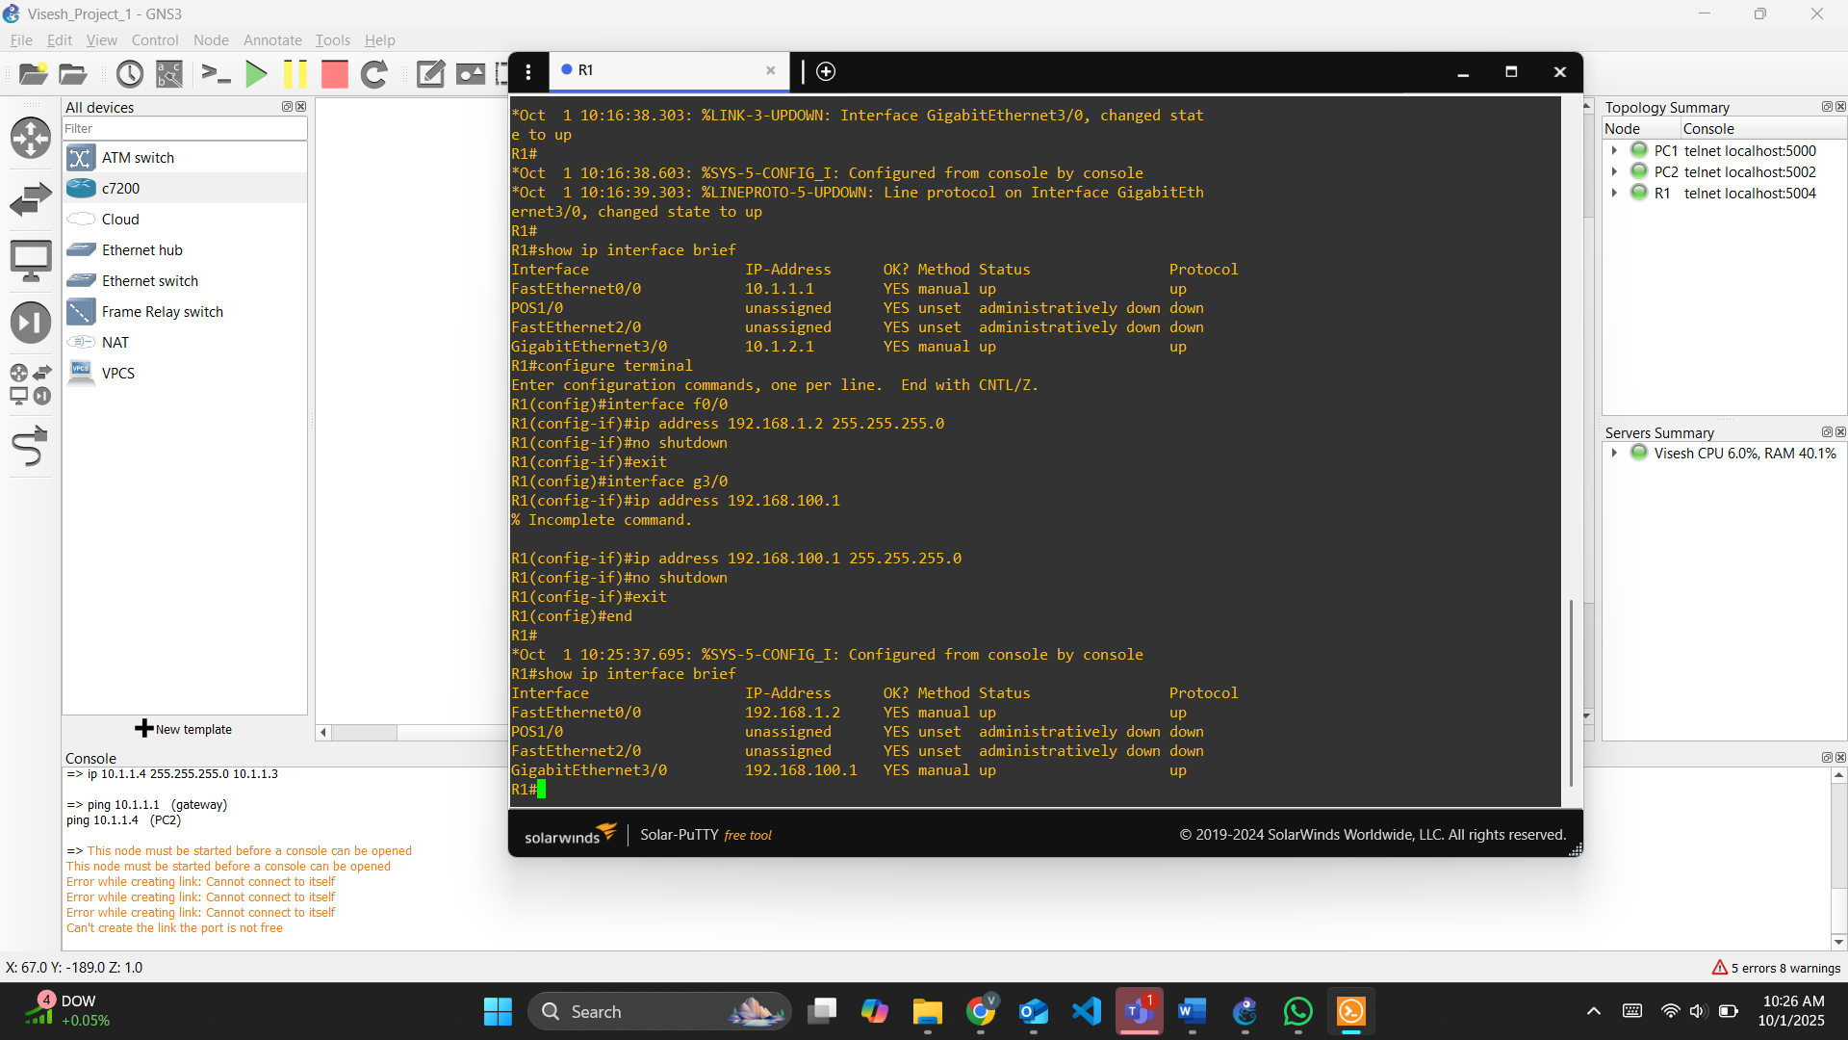
And then pc1 and we add ip address and gateway.

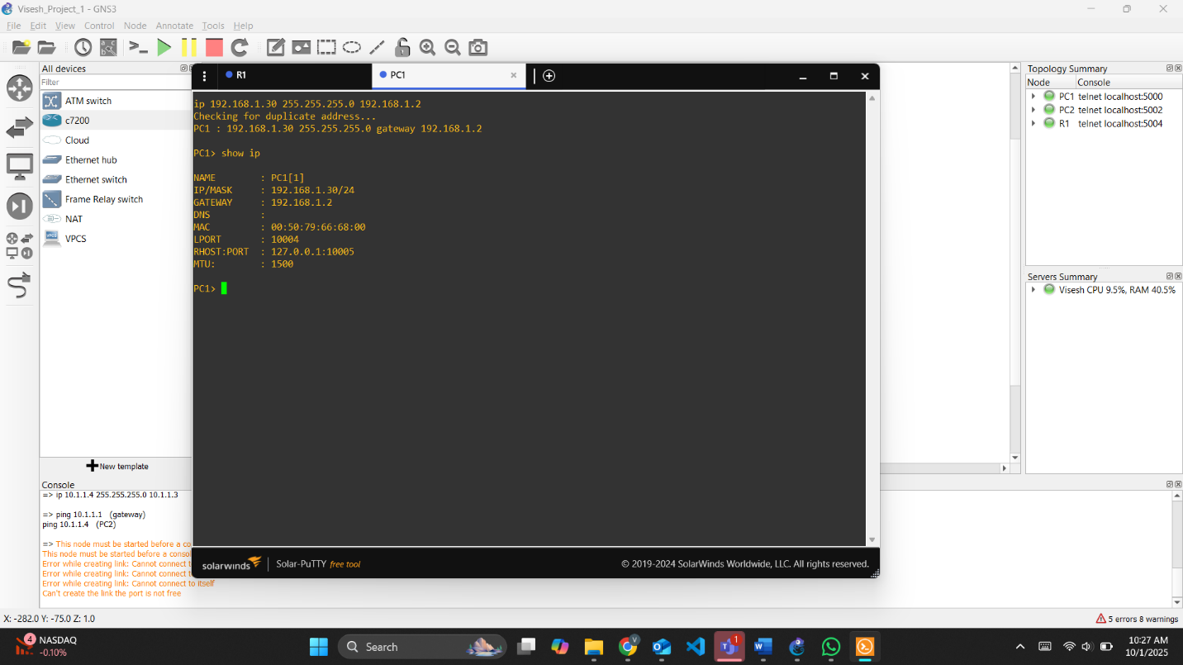
And then PC2, we add ip address and gateway. And do ping test to check the connectivity.
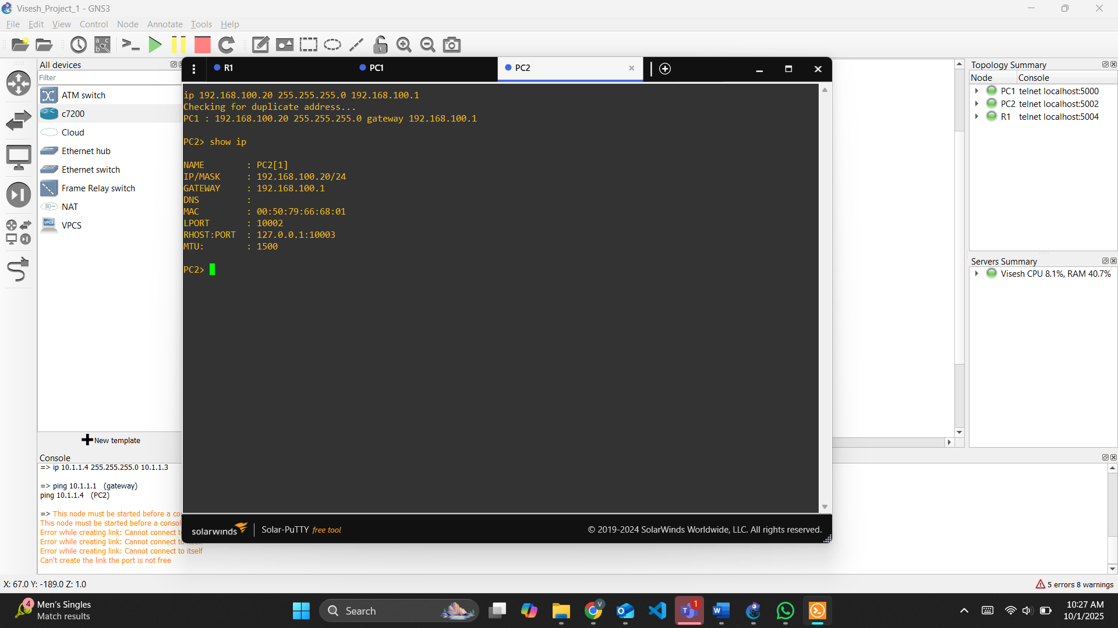
As we can there is no packet loss and connection are successful.
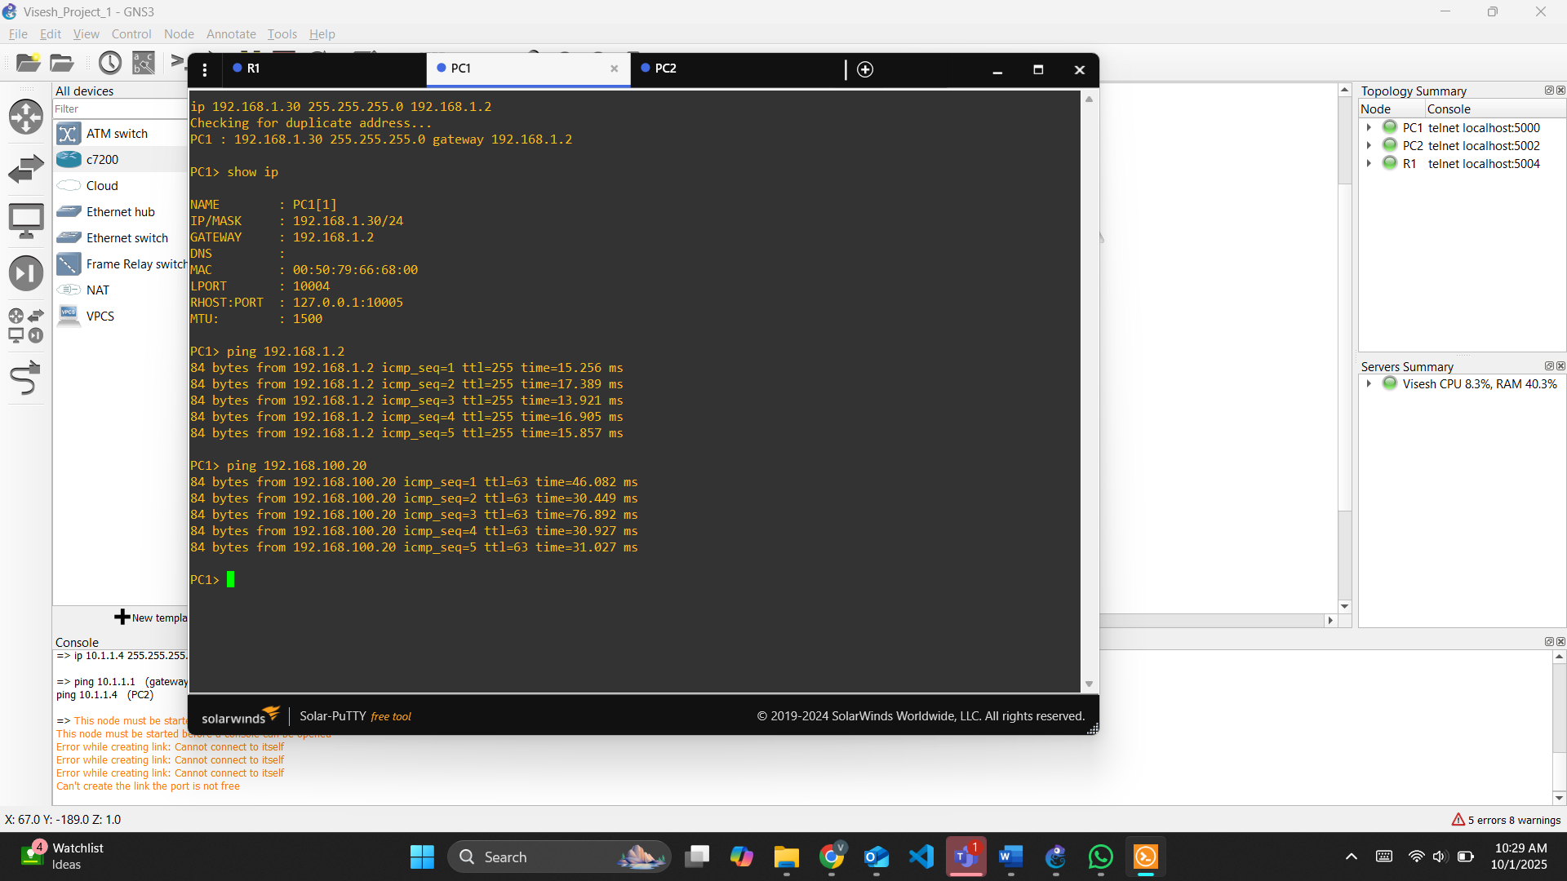

And same with pc2, the connection is successful, and we can see no packet loss.
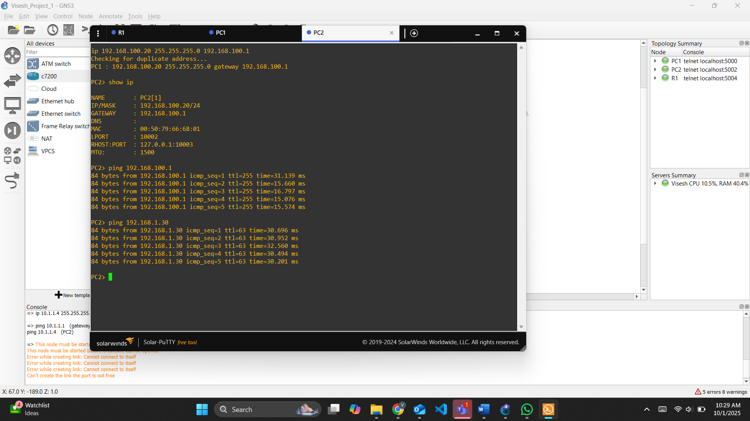

Summary
In this lab, I worked on setting up a network in GNS3 using a Cisco c7200 router and two PCs. I started by installing GNS3 and loading the IOS image to create the router. After setting up the slots and adjusting the settings, I dragged the router and two PCs into the workspace and connected them with cables. I then went into the console to configure the router and assigned IP addresses and gateways to both PCs. To make sure everything was working, I used commands like show ip and show ip interface brief and also tested the connectivity with ping. I repeated the same steps with a different set of IP addresses and again tested the connection. In the end, everything worked fine there was no packet loss and the PCs could successfully communicate with each other through the router.

Feedback
Working with GNS3 was a good experience because it gave me a more realistic feel of how networking devices function. I liked that it allowed me to use real router images and commands, so it felt like working on physical hardware. At first, the setup process was a bit tricky loading IOS images and configuring slots took some time to figure out but once it was ready, building and testing the network became straightforward. The ping tests and interface checks helped me clearly see whether the devices were connected properly. Overall, I think GNS3 is a useful tool for practicing networking concepts because it combines simulation with hands on configuration, and it makes it easier to understand how IP addressing and routing work in real networks

